2025 International Conference on Information, Implementation, and Innovation in Technology (I2ITCON) Pune, India. July 04 - 05, 2025

Signature Recognition and Forgery Detection with a Hybrid Approach using CNN and InceptionV3
2025 International Conference on Information, Implementation, and Innovation in Technology (I2ITCON) | 979-8-3315-3482-0/25/$31.00 ©2025 IEEE | DOI: 10.1109/I2ITCON65200.2025.11210728

Suresh Babu Dasari
Dept. of CSE
V R Siddhartha Engineering College Vijayawada, Andhra Pradesh, India dasarisuresh@vrsiddhartha.ac.in

Hemanth Suresh Para
Dept. of CSE
V R Siddhartha Engineering College Vijayawada, Andhra Pradesh, India phemanth1555@gmail.com

Dheeraz Chaduvula
Dept. of CSE
V R Siddhartha Engineering College Vijayawada, Andhra Pradesh, India dheerazchaduvula23@gmail.com

Abstract—Signatures are vital for identity verification in bank- ing, legal agreements, and document authentication, making their authenticity crucial due to rising fraud. Traditional methods address either signature recognition or forgery detection but independently, with no unified framework. In this work, we propose a hybrid model for signature verification that uses deep learning models, CNN and InceptionV3. We initially collect the publicly available GDPS-100 ofﬂine signature dataset Custom- Collected Signature Dataset. After preprocessing, the dataset is split into training, testing, and validation sets. We train the CNN model to identify signatures from the identity of the individual, and at the same time we train the InceptionV3 model to identify genuine and forged signatures. Person identification is done using CNN because it has the capability to learn distinctive handwriting characteristics, and forgery identification is done using InceptionV3 because it has the capability to learn features at multiple scales and is robust at detecting subtle differences. We then merge these two models into a single pipeline, which when provided with an input signature image, identifies the person and whether the signature is genuine or forged. The experiments show that this strategy effectively solves the person identification and forgery detection tasks, and it provides a unified and efficient solution for real world signature verification.
Index Terms—Convolutional Neural Networks (CNN), Deep Learning, Forgery Detection, Hybrid Approach, InceptionV3, Signature Recognition, Signature Verification

- Introduction
Signatures have been a safe form of identification for decades of individuals in various industries, such as banking, court forms, and government processes. Their handwritten nature gives them a personal touch to verification. Yet, as tech- nology advanced, so has the technique of forging signatures, rendering manual checks less reliable. There are methods such as expert forgeries, where a signature is mimicked after rigorous practice, and even AI forgeries that almost appear to be real. These limitations introduce the demand for a stronger and more automated system of signature verification to deter identity theft and document forgery.
Traditional signature verification methods are generally bi- ased towards signer identification or forgery detection [1], and they treat them as separate tasks. Though attempts at both are addressed in some works, these are tried with parallel models with minimal integration and lack the leverage to gain from shared information between the two. The difference is not suitable for real-world scenarios where a signature can
look real but attributed to the wrong person—a problem as important as forgery. Most existing solutions are biased to- wards forgery detection with the omission of proper attribution as a necessary requirement. This incompatibility results in incomplete or incorrect systems that limit their performance and validity in real-world scenarios where authenticity and proper attribution are both issues.
In order to overcome these constraints, we introduce a hybrid deep learning-based model that consolidates both signa- ture recognition and forgery detection within a single efficient pipeline. Within our method, we utilize two datasets: the publicly available GPDS-100 offline signature dataset and a locally collected dataset with signatures from 19 individu- als. Following preprocessing, both datasets are divided into training, validation, and testing sets. We train a Convolutional Neural Network (CNN) to identify individuals based on the unique signature pattern of each individual and concurrently use InceptionV3, whose deep and multi-scale feature extrac- tion ability is renowned, to detect forgeries. By combining the strengths of the two models and training on variant signature data, our system can effectively identify the signer and indicate the authenticity of the signature, providing a comprehensive and robust solution for real-world signature verification.
- Literature Review
We briefly discuss here the overview of the methods used previously.
Kiran et al. [2] created an offline signature verification system based on image processing and a Back Propaga- tion Neural Network (BPNN). Preprocessing techniques like grayscale conversion, thresholding, and Canny edge detection were applied to enhance signature readability. The prepro- cessed images were resized and input to a fixed-architecture BPNN for classifying them. Their system achieved a highest recognition rate of 93% on the dataset. The system lacked the capability to catch forgeries. It was also prone to overfitting with limited neurons and required manual tuning. These con- straints rendered the model less scalable and efficient for use in real-world scenarios.
Poddara et al. [3] utilized CNN for recognition and Crest- Trough for detection with 90-94% recognition and 85-89% detection rate. Their system was not, however, robust against

979-8-3315-3482-0/25/$31.00 ©2025 IEEE 1

variability in signatures and ran the risk of misclassifications. Harris and SURF algorithms, though good, were not effective in detecting skilled forgeries. Further, the system’s reliance on pre-defined thresholds and features made it less sensitive to changes in signature styles or conditions. These limitations imply the need for stronger systems with the capacity to handle different signature variations and improve forgery detection accuracy.
Anagha et al. [4] proposed an offline signature forgery detection and verification system using the combination of Support Vector Machine (SVM) and K-Means algorithms that reported 95.83% accuracy in forgery detection. The system applied preprocessing methods like RGB to grayscale conver- sion, image binarization, and region of interest (ROI) extrac- tion, and feature extraction techniques like contour detection and Scale-Invariant Feature Transform (SIFT). Yet, the use of static image data by the system makes it vulnerable to changes in signature styles, and the feature extraction techniques might lack the ability to handle all the variations in different signa- tures. The performance can also decrease when it is applied to skilled forgeries or changes in writing conditions like mood or health, which are not taken into consideration, so more flexible systems need to be maintained.
Hashim et al. [5] performed a comparative analysis of machine learning algorithms for handwritten signature ver- ification with the models SVM, CNN, K-NN, and DTW. They compared over 20 studies in terms of dataset, feature extraction, and classification methods. Despite tremendous advancements, challenges like high intra-class and inter-class variability of signatures, lack of adequate genuine signature samples for training, and poor detection of skilled forgeries were presented, which indicated the necessity for more reliable systems capable of accommodating varied signature styles and enhanced forgery detection.
Wang et al. [6] focus on advances in offline handwritten signature recognition, both traditional feature extraction and modern deep learning-based methods. They document the use of Convolutional Neural Networks (CNNs) to feature extraction, which are better compared to traditional methods like Histogram of Oriented Gradients (HOG) and Radon transform. There are a number of challenges in spite of these advances, according to the paper, like variability in signature styles and lack of dynamic characteristics in offline signatures, which make them more difficult to verify compared to online signatures. Challenges like sparse feature representation in offline signatures, lack of large, diverse training datasets, and multilinguality across signature samples are discussed, pointing towards the requirement of more robust and well- integrated systems in real-world applications.
Chavan et al. [7] suggested an online signature verification and forgery detection system based on a Hybrid Wavelet Transform-2 (HWT-2) and Hidden Markov Model (HMM) classifiers. They employed HWT-2 for online signature feature extraction and experimented with the system using the SVC 2004 database, obtaining low False Rejection Rate (FRR) and False Acceptance Rate (FAR) values with the best
DCT 4 and DHT 64 combination. Nevertheless, the system is marred with computational complexity, signature variability, and the challenge of detecting skilled forgeries, calling for more robust and adaptive systems.

- Proposed Methodology
In the methodology chapter, we will provide a clear description of the methods, techniques, and processes employed to attain goals.

- Model Architecture
The system proposed integrates signature verification and forgery detection into a single framework of deep learning. It employs the CNN and InceptionV3 models to offer precise, dual-output verification from signature images.


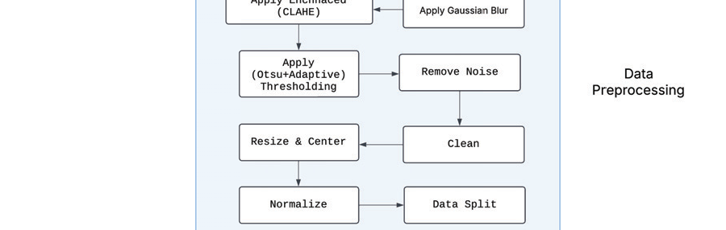
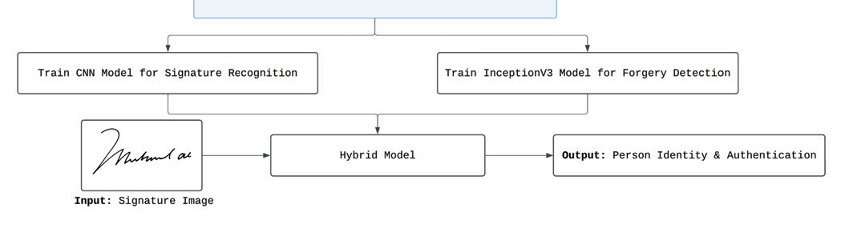
Fig. 1. Model Architecture

Figure 1 provides the architecture of this Signature Veri- fication System, covering the end-to-end process from data acquisition to end output. With the integration of the strengths of CNN and InceptionV3 models, and training on dual datasets, the system is highly accurate and reliable. The end output provides both person identification and signature genuineness, thus forming a complete and scalable solution for practical implementation of signature verification in real-world applications such as banking, legal documents, and identity verification services.
The system design is an integrated and modular deep learning system for raw signature image processing, extraction of meaningful features, and production of correct identity verification and forgery detection results. Signature data is collected from two data sources: the GPDS-100 publically available offline signature dataset and a Custom-Collected Signature Dataset of signatures of 19 individuals. Raw image data is subjected to a systematic Data Preprocessing process

that includes grayscale conversion, noise reduction through application of Gaussian blur, contrast enhancement using CLAHE, and adaptive + Otsu’s thresholding for binarization. Preprocessed data is resized, centered, normalized, and split into training, validation, and testing sets to enable effective model development.
The preprocessed signature images are then passed through two simultaneous deep learning models namely, a CNN model trained for person identification from signatures and an Incep- tionV3 model trained for competent forgery detection. The CNN identifies distinct handwriting features unique to every signer, whereas InceptionV3 is able to recognize real and forged signatures because it has the capability of multi-scale feature extraction. Both the models are utilized in tandem in a Hybrid Model (CNNception) pipeline that receives a signature image as input and identifies the signer and authenticates it simultaneously.
- Data Description
The raw signature images used as the source in this study are derived from two diverse datasets, processed individually to offer diverse training and testing. The GPDS-100 dataset contains 100 individuals with each having 54 signatures (24 real and 30 forged) with a total of 5,400 images. The Custom- Collected dataset contains 19 individuals with each having approximately 140 signatures (80 real and 60–80 forged) with a total of 3520 images. The datasets are taken individually for model training and testing to offer improved generalization and accuracy in signature verification.

Datasets
  - GPDS-100 Dataset
    - Number of individuals/persons: 100
    - Number of signatures per person: 54
    - Genuine: 24 , Forged: 30
    - Total images: 54 × 100 = 5400 images

Custom-Collected Dataset
    - Number of individuals/persons: 19
    - Number of signatures per person: 140 (approx.)
    - Genuine: 80 , Forged: 60–80
    - Total images: 3520
These two datasets are used independently in the study—each dataset is handled separately for training and evaluation, ensuring the models are exposed to distinct sets of signature data for enhanced generalization and accuracy.
- Data Preparation
The preprocessing pipeline, as illustrated in Figure 2, is designed to prepare raw signature images for tasks like sig- nature recognition and forgery detection. The process begins by loading the input image, followed by converting it into grayscale to simplify the image and focus on intensity rather than color. This step reduces the complexity of the image, making the following processing more efficient.
After grayscale conversion, a Gaussian blur is applied to smooth the image and reduce noise, enhancing the quality of

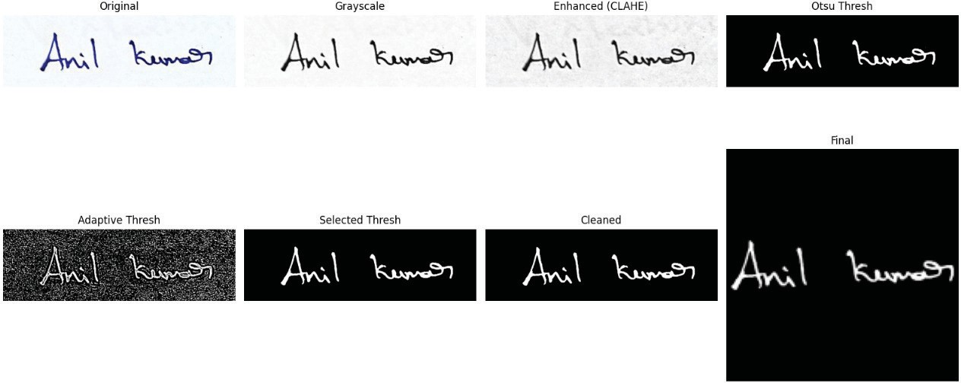

Fig. 2. Sample signature image processed through preprocessing techniques

the subsequent processing steps. CLAHE (Contrast Limited Adaptive Histogram Equalization) is then used to improve contrast, making features such as strokes and edges more visible. The image is binarized using a combination of Otsu’s and Adaptive Thresholding, which effectively separates the foreground (signature) from the background. Noise removal follows, cleaning the image of small unwanted elements, and further refinement ensures that the image is clutter-free. The image is resized to standard dimensions: 150x150 pixels for the Signature Recognition task (CNN) and 299x299 pixels for the Forgery Detection task (InceptionV3) to meet the input size requirements of the respective models.
Normalization in the later phases is employed to normalize the pixel values to enable faster and more stable machine learn- ing model training. The data is split into training, validation, and testing sets at the 80%, 10%, and 10% ratio respectively to enable proper evaluation of the models. This sequential process ensures that the image data is clean, consistent, and ready for high-performance model training.

- CNN for Signature Recognition

The CNN architecture is a 14-layered network of convo- lutional, pooling, flatten, dropout, and dense layers that is specifically designed for grayscale signature recognition with an input dimension of 150×150 pixels. Beginning with four convolutional blocks with an increasingly greater number of filters (4, 8, 16, 32), the network continues with max-pooling layers that reduce spatial dimensions and preserve salient features. This structured deep feature extraction pipeline facili- tates fine stroke pattern and texture variation extraction crucial for signature discrimination.
As shown in Figure 3, the architecture then transitions into a dense structure comprising a flattening layer and three fully connected layers with units 256, 128, and 100, respectively. A dropout layer is introduced before the final classification layer to minimize overfitting and improve generalization across unseen data. The final dense layer outputs 100 units, each corresponding to an identity class. This architecture supports both discriminative feature learning and robust classification performance.


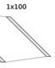
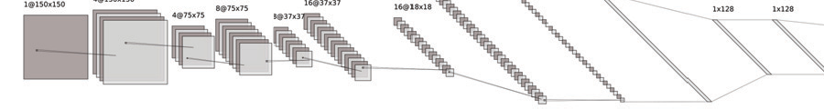

through low-level features and an InceptionV3 network for detecting forgeries using high-level abstractions. Running both models in parallel allows for complementary feature extrac- tion, leading to improved performance in signature verifica- tion.

Fig. 3. 14-Layered CNN Architecture

To optimize the model, Optuna was used as the hyperpa- rameter tuning framework to automatically search for optimal values like learning rate, dropout rate, batch size, and layer dimensions, significantly improving model efficiency and ac- curacy. Two datasets—custom and GPDS—were used entirely independently, with standard training cycles of 35 and 100 epochs, respectively, and further fine-tuned using extended training for 200 epochs. The datasets were never combined at any stage.
- InceptionV3 for Forgery Detection
The forgery detection model builds on the powerful Incep- tionV3 architecture, which serves as the core feature extractor. It begins with an input layer accepting preprocessed images of size 299×299 pixels. These inputs are then passed through InceptionV3, a deep convolutional neural network pretrained on ImageNet, capable of extracting rich hierarchical features from the signature images.
The output from InceptionV3 is flattened into a one- dimensional vector, which enables its use in fully connected layers. As illustrated in Figure 5, this representation is pro- cessed by a dense layer followed by dropout to prevent overfitting. Another dense layer further refines the features, again followed by dropout. A final dense output layer applies a softmax activation function for classification, yielding the forgery detection result.
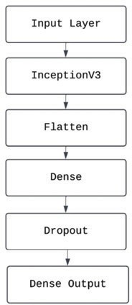
Fig. 4. InceptionV3-Based Forgery Detection Architecture

This setup balances deep feature extraction with regulariza- tion strategies, making it suitable for robust forgery detection.
- Multi-Task Parallel Hybrid Architecture
Signature verification is vital in biometric authentication, particularly in legal and financial sectors. To enhance accuracy and robustness, a Multi-Task Parallel Hybrid Architecture was developed. It combines a CNN for identifying individuals

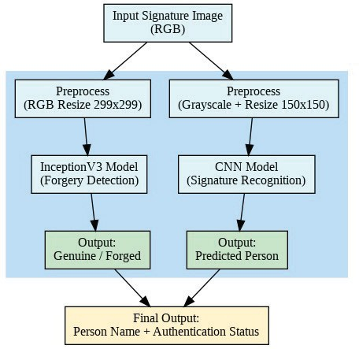
Fig. 5. Multi-Task Parallel Hybrid Architecture Workflow

As illustrated in the Figure 5, the architecture begins with a single RGB input signature image. This image is passed through two preprocessing pipelines—one that converts the image to grayscale and resizes it to 150x150 pixels for the CNN model, and another that resizes the RGB image to 299x299 pixels for the InceptionV3 model. These parallel branches independently process the input through their re- spective models to generate feature outputs. The CNN branch outputs the predicted person (identity), while the InceptionV3 branch determines the signature’s authenticity (genuine or forged). Both outputs are then fed into a final stage where they are merged to provide a comprehensive result that includes both the person’s identity and the authentication status.
This hybrid strategy of combining both paths significantly enhances classification efficiency and ensures even higher gen- eralizability across diverse handwriting styles and complexities of signatures. Low- and high-level feature learning separation enables the model to be highly generalizable and attuned to finer variation in signature patterns. Additionally, architectural modularity enables smooth scalability and optimization, in which it is well-positioned to be a versatile tool in real- world signature verification systems, where fraud detection and identity verification are of paramount concern. Blending recognition with forgery detection into a single framework, the architecture exhibits efficiency and wisdom through the use of multitask learning.

- Result and Analysis
This section presents results from a hybrid deep learning model that integrates CNN and InceptionV3 for signer authen- tication and forgery identification. The outputs were combined after training on a labeled dataset to enhance performance. The model identified the signer correctly and marked signatures as authentic or forged, and evaluation was done on accuracy, precision, and recall. Visual outputs and performance metrics validate its efficacy.

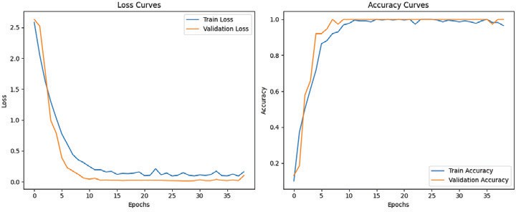

Fig. 6. Training Metrics for CNN on Custom-Collected Dataset
0.3432 , indicating strong performance in learning to classify signatures effectively.
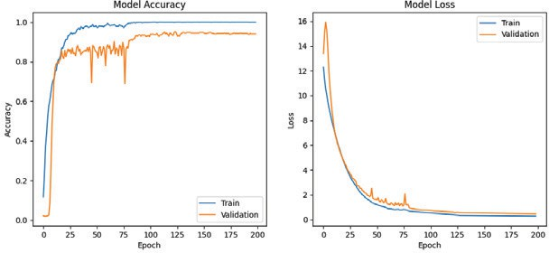
Fig. 10. Training Metrics for CNN on GDPS-100 Dataset

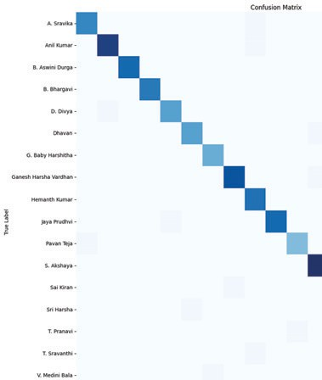
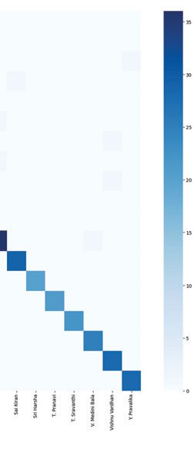
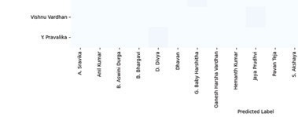
Fig. 7. Confusion Matrix for CNN on Custom-Collected Dataset

Figure 6 and Figure 7 represents the training metrics and confusion matrix for the CNN model trained on the Custom-Collected dataset for Signature Recognition. The CNN achieved an accuracy of 98% and a final loss value of 0.2442 , indicating strong performance in learning to recognize signatures effectively.
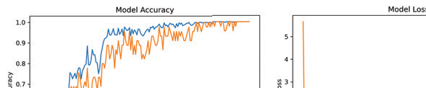
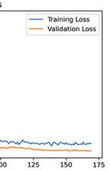
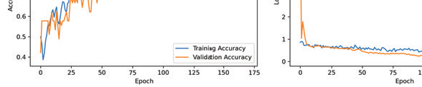
Fig. 8. Training Metrics for InceptionV3 on Custom-Collected Dataset

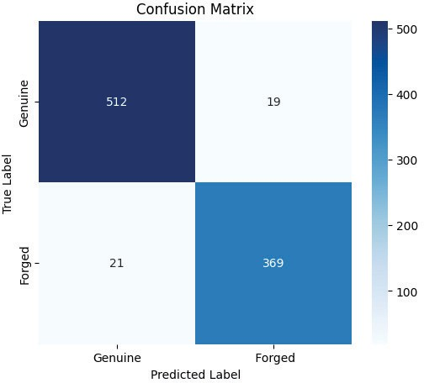

Fig. 9. Confusion Matrix for InceptionV3 on Custom-Collected Dataset

Figure 8 and Figure 9 represents the training metrics and confusion matrix for the InceptionV3 model trained on the Custom Collected dataset for Forgery Detection. The Incep- tionV3 achieved an accuracy of 97% and a final loss value of

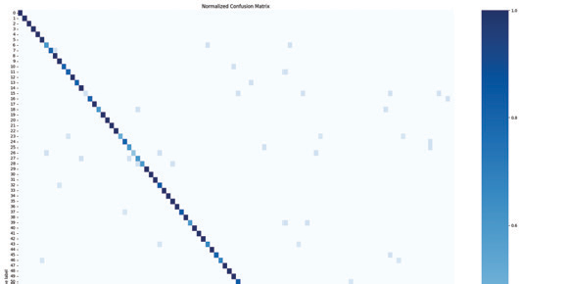
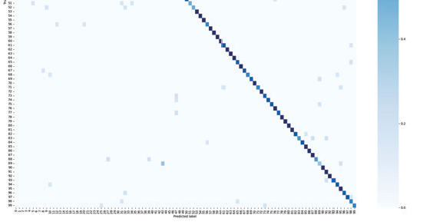
Fig. 11. Confusion Matrix for CNN on GDPS-100 Dataset

Figure 10 and 11 represents the training metrics and con- fusion matrix for the CNN model trained on the GDPS- 100 dataset for Signature Recognition. The CNN achieved an accuracy of 95.3% and a final loss value of 0.4623 , indi- cating strong performance in learning to recognize signatures effectively.
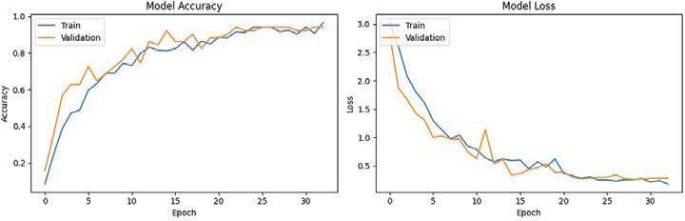
Fig. 12. Training Metrics for InceptionV3 on GDPS-100 Dataset

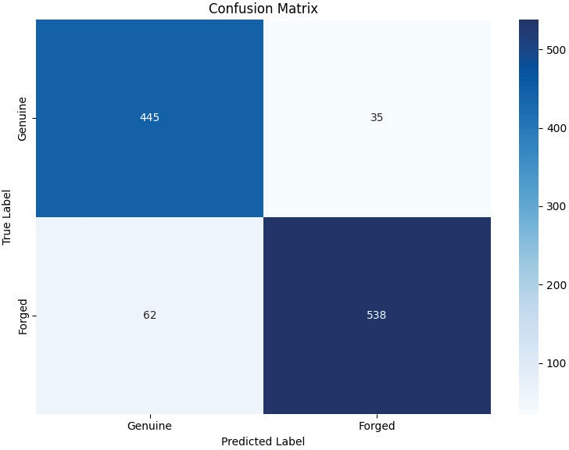

Fig. 13. Confusion Matrix for InceptionV3 on GDPS-100 Dataset

Figure 12 and Figure 13 represents the training metrics and confusion matrix for the InceptionV3 model trained on the

GDPS-100 for Forgery Detection. The InceptionV3 achieved an accuracy of 92% and a final loss value of 0.2432 , indicating strong performance in learning to classify signatures effectively.

TABLE I
Accuracy Comparison on Datasets

Model | Custom Dataset | GDPS-100
CNN | 98% | 95.3%
InceptionV3 | 97% | 92%
Hybrid | 95%(0.98*0.97) | 88%(0.95*0.92)

Table I presents the accuracy comparison of models on the Custom Collected Dataset and GDPS-100. On the Custom Collected Dataset, CNN achieved the highest accuracy of 98%, followed by InceptionV3 with 97%. These results are notably higher than the corresponding accuracies on the GDPS-100 dataset, where CNN and InceptionV3 obtained 95% and 92%, respectively. This improvement can be attributed to the Custom Collected Dataset containing more images per signer (approx- imately 140), enabling the models to better learn individual signature patterns. Hence, a larger number of samples per signer contributes to improved classification and verification accuracy.

TABLE II
Comparison on Signature Recognition Models

Model | Accuracy
7-CNN | 94%
SVM | 94%
BPNN | 93%
14-CNN | 98%

Table II showcases the performance of various models on signature recognition tasks. Our proposed 14-CNN model outperformed all other methods with an accuracy of 98%, demonstrating its superior feature extraction capability. Other models like 7-CNN, SVM, and BPNN also showed strong results but remained slightly lower in accuracy, emphasizing the effectiveness of deeper CNN architectures.

TABLE III
Comparison on Forgery Detection Models

Model | Accuracy
Harris and SIFT Algorithm | 89%
Multi-Layer Perceptron (MLP) | 91.48%
Random Forest (RF) | 90.73%
SL | 86.53%
ResNet-101 | 96%
InceptionV3 | 97%

Table III presents accuracy comparisons among forgery detection models. Our InceptionV3 model achieved the high- est accuracy of 97%, outperforming traditional methods like Harris and SIFT, MLP, Random Forest, ResNet-101 and SL. This highlights the superior effectiveness of deep learning, particularly InceptionV3, in forgery detection
- Conclusion And Future Work
The hybrid deep learning model combining CNN and In- ceptionV3 has demonstrated strong performance in signature recognition and forgery detection. Using CNN for signer iden- tification and InceptionV3 for forgery detection, the system accurately classifies signatures. Results from both the custom dataset and GDPS-100 validate the model’s efficiency, with higher accuracy observed in the custom dataset (140 samples per signer), highlighting the importance of a larger sample size for improved performance. This indicates that the model is better able to capture intra-class variations, which enhances its ability to generalize across different signature samples.
Looking forward, the model can be improved by incorpo- rating a wider variety of signature styles, multiple scripts, and languages to boost generalizability. Future advancements may include exploring cutting-edge techniques like attention mechanisms or transformer-based models. Additionally, de- ploying the system on web or mobile platforms with secure cloud integration could bring practical applications in fields like banking, legal services, and authentication.
References
- G Manoj Kumar, P Satyanarayana, B Sridhar, K Tejo Rohith, GVS Padma Rao, and V Gokula Krishnan. Deep neural networks based handwritten signature verification using machine learning algorithms. In 2024 Asian Conference on Intelligent Technologies (ACOIT), pages 1–6. IEEE, 2024.
- P Kiran, BD Parameshachari, J Yashwanth, and KN Bharath. Offline signature recognition using image processing techniques and back propagation neuron network system. SN Computer Science, 2(3):196, 2021.
- Jivesh Poddar, Vinanti Parikh, and Santosh Kumar Bharti. Offline signature recognition and forgery detection using deep learning. Procedia Computer Science, 170:610–617, 2020. The 11th International Conference on Ambient Systems, Networks and Technologies (ANT) / The 3rd International Conference on Emerging Data and Industry 4.0 (EDI40) / Affiliated Workshops.
- R Anagha and Chandan Kumar. Signature recognition and forgery detection. Authorea Preprints, 2023.
- Zainab Hashim, Hanaa M Ahmed, and Ahmed Hussein Alkhayyat. A comparative study among handwritten signature verification methods using machine learning techniques. Scien- tific Programming, 2022(1):8170424, 2022.
- Zhaoya Wang, Mahpirat Muhammat, Nurbiya Yadikar, Alimjan Aysa, and Kurban Ubul. Advances in offline handwritten signa- ture recognition research: A review. IEEE Access, 11:120222– 120236, 2023.
- Manoj Chavan. Handwritten online signature verification and forgery detection using hybrid wavelet transform-2 with hmm classifier. J. Electr. Syst, 20(4s):2463–2470, 2024.

